Issue No: 2, Published on 31stMay 2021, by UDAYAN CARE | A.R.T.
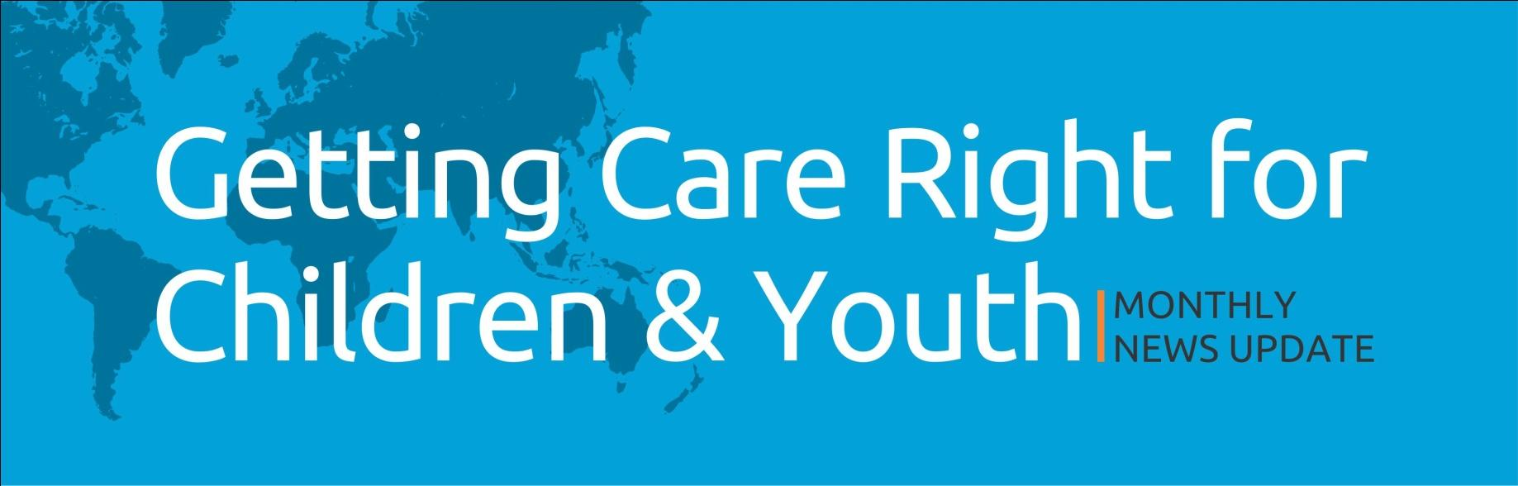

Note: This monthly wrap up is intended to serve as a compendium of the latest developments in the area of alternative care. We hope you will find it useful and be able to use it in your day to day work on research, writing and practice on child and youth care. Reach out to us at icbjournal@udayancare.org for any suggestions or feedback on the newsletter. We look forward to your inputs.
GENERAL ALTERNATIVE CARE NEWS

INTERNATIONAL:
- The preferably unheard
- Turkish aid gives lifeline to orphanages in South Sudan
- Middle East/North Africa: End Violent Punishment of Children
- 'No good choices': HHS cuts safety corners to move migrant children out of overcrowded facilities
- Displaced Children in Central African Republic Risk Forced Recruitment, Gender-Based Violence

ASIA:
- Nepal: Covid-19 Pandemic Fueling Child Labor
- Afghanistan: Nearly 1,600 child casualties in the past five years

- UNICEF says Covid-19 hitting children hard in South Asia
- Pandemic Family Life: The Struggles Behind Closed Doors
- Deadly new surge in South Asia threatens to reverse global gains against the COVID-19 pandemic and have disproportionate impact on children

INDIA:
- SC in coordination with UNICEF highlights need to protect children orphaned by COVID-19
- Covid orphans: Child rights body issues a caution
- COVID-19: Many institutions for child welfare, but in need none step up: HC
- Need to step up measures for well-being, protection of children during COVID-19 second wave: SC judge
- Ministry of Women forms task force to help Covid-hit children

NEWS RESOURCES (PUBLICATIONS, RESEARCH PAPER, STUDY, TOOL KIT, POLICY BRIEF) IN ALTERNATIVE CARE SPACE

- Afghanistan: Safe Reopening of Child Friendly Spaces (CFS) and other Psychosocial Support (PSS) Group Activities Action Tracker
- First Years, First Priority: A Fair Start for Every Child in Europe Policy Brief
- A guide - children & the Global Compacts on refugees & migration: Understanding what’s in the Compacts and how to engage with them
- May 2021 toolkit: Mental Health Awareness Month

ADVOCACY/IMPACT/DATA/CALL FOR PROPOSALS/ FELLOWSHIP RELATED NEWS
- COVID-19: NIMHANS to address anxiety faced by orphans
- Save the Children fears trafficking and abuse amid social media pleas to adopt India’s Covid orphans
- REQUEST FOR PROPOSALS – EXTERNAL EVALUATION (Hope and Homes for Children)
- Call for Submission of Written Contributions/Videos for 2021 UNCRC Day of General Discussion on Children's Rights and Alternative Care

YOUNG VOICES THAT APPEAR IN MEDIA
- Driven by own experience, Mumbai man works for a better future for care-leavers
- Maryanne has changed the system so Devon Care Leavers can find the home they want
- Comment Kenneth Murray: Caring about care experience
- Crafty Betty on London Road, Newark, appointed as Nottinghamshire representative for Quilts For Care Leavers
- Mathira wants to adopt a Palestinian child

COUNTRY SPECIFIC DEVELOPMENT IN ALTERNATIVE CARE

INTERNATIONAL:
- The University Of Manchester Signs The Care Leaver Covenant
- Pending shutdown of foster care home looms as state officials take control of county system
- What can be done for Haitian orphans in the time of COVID-19 | Opinion
- How the Women’s Prison Association Is Working to Keep Mothers With Their Children

ASIA:
- Alkhidmat Foundation: Striving to help orphans shine
- AJK President pledges extra care for orphans, vulnerable children

INDIA:
- COVID: Andhra Pradesh to Establish 32 Child Care Institutions for Families Hit By Pandemic
- Delhi Govt. opens two quarantine centers for unattended, rescued children
- Odisha Govt. Directs To Rehabilitate Children Whose Parents Are At COVID Care Centers
- Haryana approves policy for welfare of abandoned, surrendered children
- Ministry of Women and Child Development Engages With Indian Academy Of Pediatrics To Provide Expert Care To Children At Govt. Child Care Institutions
- MP announces free education for children orphaned due to COVID

OPPORTUNITIES AND EVENTS (JOBS, CONFERENCE ALERTS, CALL FOR ABSTRACTS)
- Global & European Trends of Deinstitutionalisation for Children
- Event Information: The Early Years Fellowship: Building the next generation of leaders in early childhood
- Breaking the Cycle: Protection, Resilience & Recovery for Street Connected Children
- Creating lasting change for children in alternative care
- 3rd World Virtual Conference on Children and Youth 2021

Subscribe
Call for Papers- Institutionalised Children Explorations and Beyond

